Oklahoma Business Ethics Consortium
August 9, 2006 ~ 11:30 to 1:00
Agenda

I. WELCOME & KUDOS Shannon Warren, Founding Director
  - Connie Barwick – Maximum Multi Media Creations for the pre-meeting Power Point presentations
  - The Accel Financial Staffing Team for their efforts in ensuring a smooth registration process
  - Josie Strickland of Principal Technologies for the FIRST STAR MEMBERSHIP OF 2006-07!!!!
  - Welcome Susan Lane, new accounting service for OkEthics! Susan started on Friday and will be helping with our bookkeeping, billing, meeting registration and other important tasks.
  - Shannon Hiebert – Vice President, Membership
Shannon Hiebert, Enterprise Rent-A-Car HR Manager, was named as one of the five employees who have helped fuel the Company’s success, according to an internal announcement issued by Andy Taylor last week. Shannon, along with four other honored employees, will be joining the officers of the company at the Fall Officers Meeting in New York City where she will be acknowledged for her contributions under the category of "Having Integrity".
OkEthics salutes Shannon for her work as a founding member of this organization! We are proud of you!

***OKETHICS COMPASS AWARD RECIPIENTS***
Congratulations to Eide Bailly & Valir Health – OkEthics FIRST Compass Award Recipients!
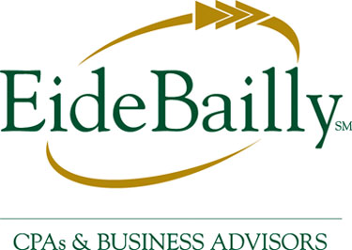
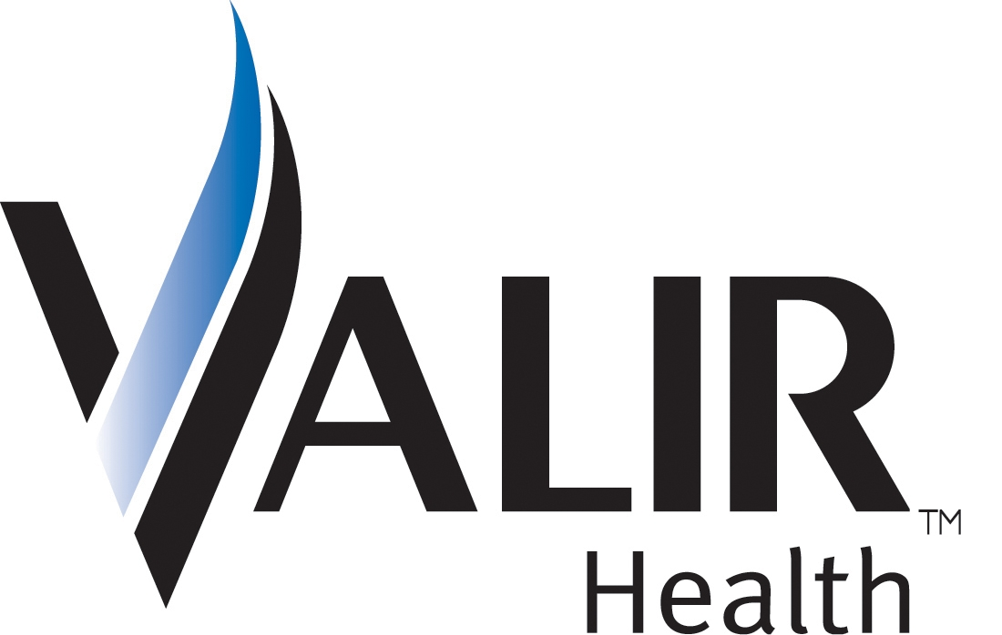

- GET INVOLVED!
The Membership and Public Relations Committees work together to help OkEthics flourish across the state. To do this important work, they need enthusiastic volunteers. If you are interested in serving as a volunteer to promote Oklahoma values in the workplace, please call Valerie Fried, VP of Public Relations at ValerieF@CapitolAbstract.com or 810-2457 or Shannon Hiebert at 330-9191.
REGISTRATION HELP NEEDED! Starting next month, we will need to begin the transition process to a new registration team. Volunteers are needed who can provide a consistent and reliable presence at the meetings. Call Shannon Warren at 858-2233.
NOTE: Members of the Oklahoma Business Ethics Consortium frequently share information concerning various issues and developments that may have legal implications. The discussions, commentary, and handouts at Consortium meetings or presentations to other organizations are for general informational purposes only. They cover only some aspects of the subject topic, and do not constitute a complete legal analysis of the topic or how it might apply to any particular set of facts. Before taking any action based on information presented by a Consortium member, participants are encouraged to consult a qualified attorney. The observations and comments of presenters at Consortium meetings and networking are the views and opinions of the presenter and do not constitute the opinion or policies of the Consortium or any of its members.
__________________________________________
YOU MAY REGISTER FOR ANY UPCOMING PROGRAMS THROUGH OUR WEBSITE AT www.okethics.org OR CALL 858-2233.

III. UPCOMING CONSORTIUM EVENTS

OKC Chapter
September 13 – “Ethics & The Media”
Presented by Channel 9 News Reporter
Alex Cameron

October 11 – “Lies! Lies! Lies”
Presented by Dr. Charles Ford,
noted author & psychiatrist
**CPE Credit**
November 8 – “Character & Integrity”
Presented by OCU’s Business Dean,
Dr. Vince Orza
**CPE Credit””

December 13 – “Strong Character Guides Professional Conduct” ***CLE CREDIT***

A study of the Character behind the Oklahoma Rules of Professional Conduct
Co-Sponsored by the Character Council of Central Oklahoma
Presented by Jack Gilchrist, Debee Gilchrist Law Firm

IV. Other Programs Related to Ethics
Character First – Business Leaders Breakfast/Luncheon
“Diligence in the Workplace”
Tuesday, August 22: 7:00 a.m. – 8:00 a.m.
Thursday, August 24: Noon – 1:00 p.m.
RSVP: 815-0001 or visit the Character Council Website at http://www.characterok.org/

Guiding Principles Garyl Geist, CEO of Valir Health
(2006 OkEthics Compass Award Recipient)

Keynote: Chris Wilson, CEO of Wilson Research Strategies 12:15
“Corporate Reputation & The Bottom Line”

VII. ADJOURN 1:00

PLEASE HELP US CONTROL COSTS – LEAVE YOUR NAME TAG WITH US!

