Oklahoma Business Ethics Consortium
January 11, 2006 ~ 11:30 to 1:00
Agenda

I. Welcome & Announcements 11:45
- Shannon Warren
OkEthics Founding Director

II. Kudos
    - Connie Barwick, Dept. of Corrections (AV & PowerPoint)
    - Tammy Wood, Valir Health (Nametags)
    - Special Guest: Representative Jari Askins
    - New Member: David Castillo, Greater OKC Hispanic Chamber of Commerce

III. Upcoming Consortium Meetings

OKC Chapter
February 8 – Paul Mott, President, The Hornets

March 8 – Susan Savage, Oklahoma Secretary of State

MOORE-NORMAN CHAPTER MEETING:
Members in OKC chapter may participate in other Chapter activities at the regular member rate. To make reservations, visit our website at www.okethics.org

January 18 – Steven Menzel, Character First Institute, “Self Control”

February 15 – Jim Priest, Attorney with Whitten, Nelson & McGuire

TULSA CONSORTIUM MEETINGS:
January 26 – “Ethical Leadership: A View from the Dark Side” by Dr. Robert Hogan,

Hogan Assessments

February 23 – “Ethics in the News Business”
Tulsa World Managing Editor,
Susan Ellerbach & Business Editor,
John Stancavage

March 23 – Stan Clark, Eskimo Joe’s

Other Programs Related to Ethics:
Character First – Business Leaders Breakfast/Luncheon
Topic: “Resourcefulness in the Workplace” by John Burnett
Dates & Times: Tuesday, January 24 7:00 a.m. – 8:00 a.m.
Thursday, January 26 Noon to 1:00 p.m.
Location: Character First Institute, 520 West Main Street
Cost: Complimentary
RSVP: 815-0001 or visit the Character Council Website at http://www.characterok.org/

Sue Hale, Editor of The Oklahoman will be conducting a book signing “Nursing Home Diary:
A Lesson in Survival” on February 23 at The Fountains at Canterbury, 1402 NW 122nd; Contact Debie Weaver at 751-3600 to attend the event free of charge.

VIII. Opening Remarks Noon
Senator Connie Johnson
IX. Introduction John Burnett,
Founding OkEthics Member;
Character First Institute

X. Keynote Speaker Thomas Hill, COO,
Kimray Inc.

XI. Adjourn 1:00

PLEASE HELP US CONTROL COSTS –
LEAVE YOUR NAME TAGS WITH US!

NOTE: Members of the Oklahoma Business Ethics Consortium frequently share information concerning various issues and developments that may have legal implications. The discussions, commentary, and handouts at Consortium meetings or presentations to other organizations are for general informational purposes only. They cover only some aspects of the subject topic, and do not constitute a complete legal analysis of the topic or how it might apply to any particular set of facts. Before taking any action based on information presented by a Consortium member, participants are encouraged to consult a qualified attorney. The observations and comments of presenters at Consortium meetings and networking are the views and opinions of the presenter and do not constitute the opinion or policies of the Consortium or any of its members.

OK-ETHICS MEMBERS: THANK YOU FOR LIGHTING THE WAY!

OKLAHOMA STARS




leading members
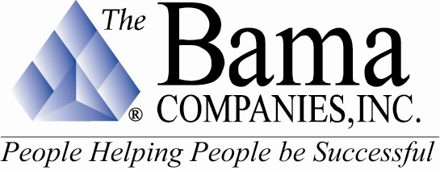




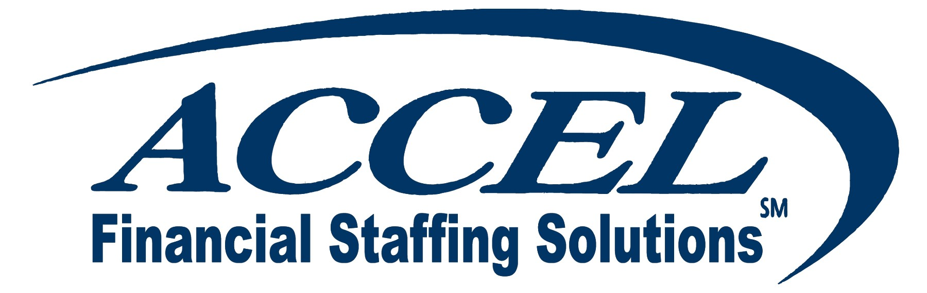
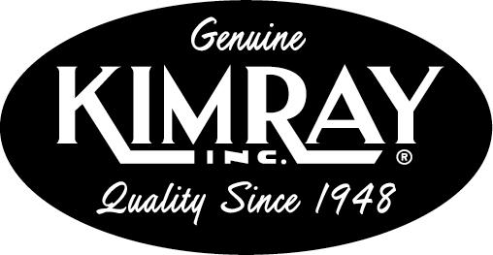

Sustaining Members:

Bill Bleakley, OKCBusiness Roger Hicks, Hicks & Associates
Stan Martin, HealthHistories, Inc. Blaine Rider, Digital West

Fellowship Members:

Jacque | Bergman | Kerr-McGee,
Lynnda | Berryhill | Berryhill Insurance Agency. Inc.
Myrna S. | Latham | McAfee & Taft
Mary | Melon | The Journal Record
David | Rhoades | Fraud & Forensic Investigations
Shannon | Warren | Warren Consulting LLC
Debie | Weaver | The Fountains at Canterbury

CORPORATE MEMBERS:

Beale Professional Services
Boeing Company, The
Cole & Reed
CoorsTek
Coppermark Bank
Cox Communications - Oklahoma
Edward Jones (OKC)
Edward Jones Investments (Tulsa)
Enterprise Rent-A-Car
Epworth Villa Life Care Community
EWF International
Foundation Surgery Affiliates. Inc.
Gooden Group. Inc., The
Gray & Company. P.C. CPAs
Greater OKC Hispanic Chamber
Hogan & Slovacek
Holy Trinity Charismatic Episcopal Church
Langston University/Oklahoma City
Leader Communications. Inc.
Lisle Compton Cole & Almen LLP
Metro Technology Centers
Moore Norman Technology Center
Norris
Oklahoma Center for Non-Profits
Oneok. Inc.
Sharron’s Designs
Staffmark
State Chamber of Oklahoma
Third Degree Advertising
University of Central Oklahoma
University of Oklahoma
College of Arts and Sciences
University of Tulsa. The
Valir Health
Williams Companies
Woodrum Kemendo & Cuite

We are in the process of renewing memberships and were unable to list individual members at this time. If you do not see your name on this list and have already renewed or joined at the Corporate level and above, please notify Shannon Warren at (405) 858-2233 as soon as possible so that we may make corrections. Thank you for your patience!

TO JOIN THE OKLAHOMA BUSINESS ETHICS CONSORTIUM,
VISIT OUR WEBSITE AT HTTP://WWW.OKETHICS.ORG

