Oklahoma Business Ethics Consortium
July 12, 2006 ~ 11:30 to 1:00
Agenda

I. WELCOME & KUDOS Shannon Warren, Founding Director
  - Character First Institute Directors & Staff – Use of Facility
  - Joshua Jantz – Coordinated this event

***OKETHICS COMPASS AWARD RECIPIENTS***
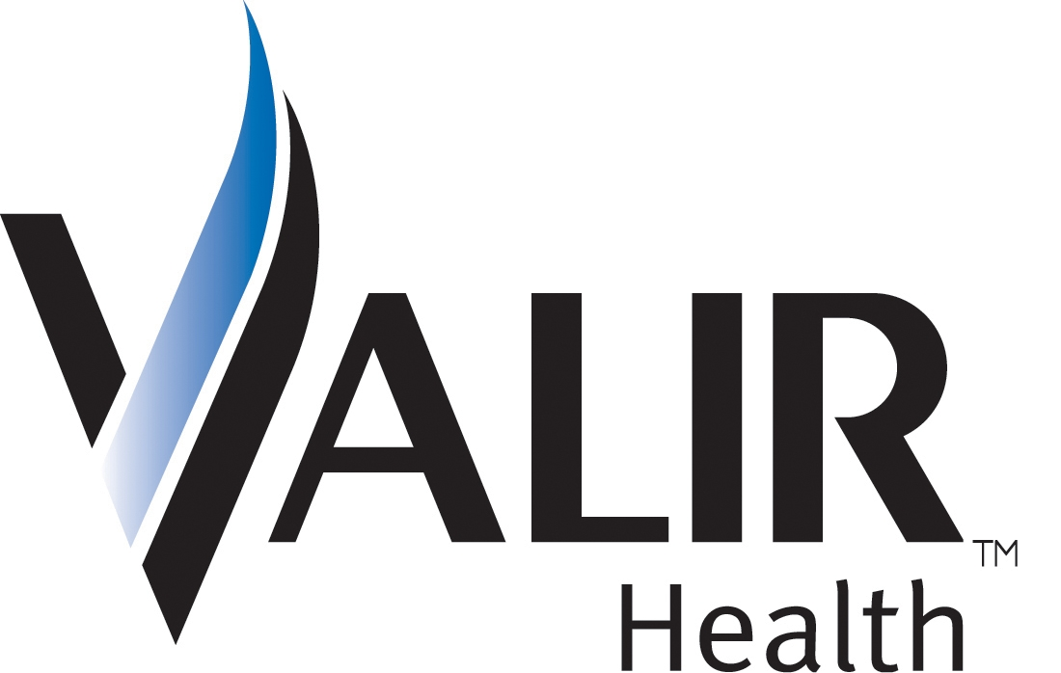
Congratulations to Eide Bailly & Valir Health – OkEthics FIRST Compass Award Recipients!
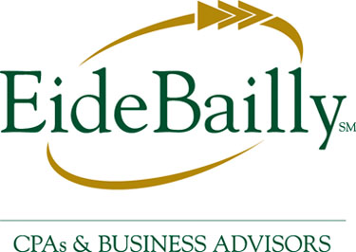

- GET INVOLVED!
The Membership and Public Relations Committees work together to help OkEthics flourish across the state. To do this important work, they need enthusiastic volunteers. The next meeting will be held Monday, July 24 at the offices of Capitol Abstract. If you are interested in serving as a volunteer to promote Oklahoma values in the workplace, please call Valerie Fried at ValerieF@CapitolAbstract.com or 810-2457 ASAP.
NOTE: Members of the Oklahoma Business Ethics Consortium frequently share information concerning various issues and developments that may have legal implications. The discussions, commentary, and handouts at Consortium meetings or presentations to other organizations are for general informational purposes only. They cover only some aspects of the subject topic, and do not constitute a complete legal analysis of the topic or how it might apply to any particular set of facts. Before taking any action based on information presented by a Consortium member, participants are encouraged to consult a qualified attorney. The observations and comments of presenters at Consortium meetings and networking are the views and opinions of the presenter and do not constitute the opinion or policies of the Consortium or any of its members.
__________________________________________
YOU MAY REGISTER FOR ANY UPCOMING PROGRAMS THROUGH OUR WEBSITE AT www.okethics.org OR CALL 858-2233.

III. UPCOMING CONSORTIUM EVENTS

OKC Chapter
August 9 – “Corporate Reputation & The Bottom Line”
Presented by Chris Wilson,
CEO of Wilson Research Strategies
October 11 – “Lies! Lies! Lies”
Presented by Dr. Charles Ford,
noted author & psychiatrist
**CPE Credit**
November 8 – “Character & Integrity”
Presented by OCU’s Business Dean,
Dr. Vince Orza
**CPE Credit””

Moore-Norman Chapter:
July 19 – “Immigration Issues & Ethical Implications for Business”
Presented by Jon Viele, Attorney with Viele & Viele

Tulsa Chapter:
July 27 – TU Coach Kragthorpe

IV. Other Programs Related to Ethics
Character First – Business Leaders Breakfast/Luncheon
RSVP: 815-0001 or visit the Character Council Website at http://www.characterok.org/

V. Peter Dobelbower, Chief Legal Officer, Hobby Lobby Stores, Inc. Noon

VI. ADJOURN 1:00
PLEASE HELP US CONTROL COSTS – LEAVE YOUR NAME TAG WITH US!

