Oklahoma Business Ethics Consortium
May 10, 2006 ~ 11:30 to 1:00
Agenda

I. Welcome & Kudos Bob Byrne; President OkEthics Foundation
  - Connie Barwick, Maximum Multi-Media Creations (PowerPoint)
  - Nextep, Norman Chapter’s FIRST Leading Member!
  - Fraud & Forensic Investigations, Leading Member
  - Mark Luff of Fraud & Forensics for lending his great technical expertise in a
data recovery effort
  - Chris Wilson of Wilson Research Strategies for helping us line-up great speakers like Mayor Cornett and Joe Castiglione

- S.O.S. HELP WANTED!
Growing Pains! We need bookkeeping and monthly administrative services!!!!
Please call 858-2233 ASAP to submit bids.

- OKETHICS COMPASS AWARD
Congratulations to Eide Bailly & Valir Health – OkEthics FIRST Compass Award Recipients!
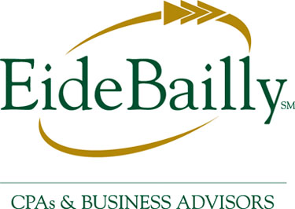


NOTE: Members of the Oklahoma Business Ethics Consortium frequently share information concerning various issues and developments that may have legal implications. The discussions, commentary, and handouts at Consortium meetings or presentations to other organizations are for general informational purposes only. They cover only some aspects of the subject topic, and do not constitute a complete legal analysis of the topic or how it might apply to any particular set of facts. Before taking any action based on information presented by a Consortium member, participants are encouraged to consult a qualified attorney. The observations and comments of presenters at Consortium meetings and networking are the views and opinions of the presenter and do not constitute the opinion or policies of the Consortium or any of its members.

IV. Upcoming Consortium Meetings

OKC Chapter
June 14 – Special Joint Meeting with IMA –
CPE Credit available (see attached)
July 12 – Peter Dobelbower, General Counsel,
Hobby Lobby Inc. “The Human Touch”

TULSA CONSORTIUM MEETINGS:
May 25 – Panel Discussion: “Why Ethics Programs Fail”
June 22 – SpiritBank CEO Kell Kelly
July 27 – TU Coach Kragthorpe

Other Programs Related to Ethics:
Character First – Business Leaders Breakfast/Luncheon
RSVP: 815-0001 or visit the Character Council Website at http://www.characterok.org/

VI. Introduction Chris Wilson
Wilson Research Strategies

VII. Keynote Speaker Joe Castiglione OU’s Athletic Director

VIII. Adjourn 1:00
PLEASE HELP US CONTROL COSTS – LEAVE YOUR NAME TAGS WITH US!

