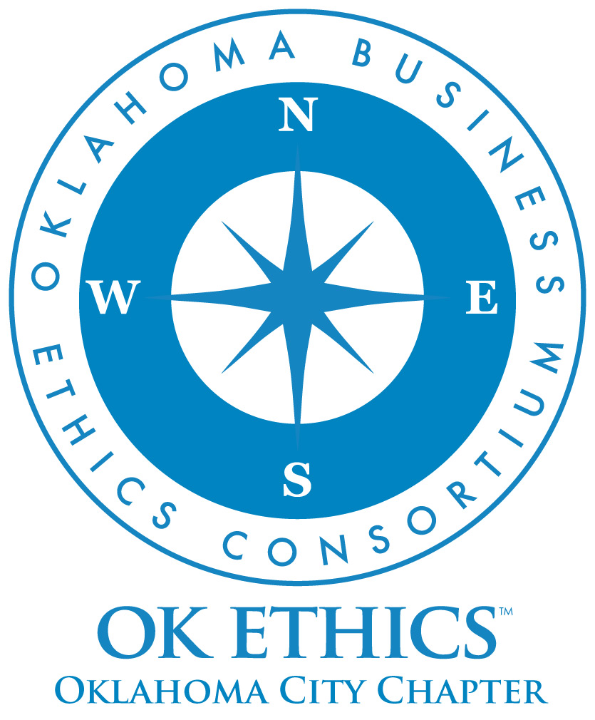
SUMMER SYMPOSIUM
AUGUST 11, 2010
OKLAHOMA CITY UNIVERSITY
MEINDERS SCHOOL OF BUSINESS
2501 North Blackwelder ~ Oklahoma City, Oklahoma

WWW.OKETHICS.ORG

CPE CERTIFICATES

It is the responsibility of participants to demonstrate applicability of each program for demonstration of earned CPE credits, to his/her area of practice. OK Ethics makes no guarantees. Also, attendees must be present to accept CPE certificates that will be issued at the conclusion of the program.
Please note that we
do not have the manpower capabilities
to email these later.
Also, you must be registered on our attendance list
to receive a certificate.

GENERAL DISCLAIMER

Members of the Oklahoma Business Ethics Consortium frequently share information concerning various issues and developments that may have legal implications. The discussions, commentary, and handouts at Consortium meetings or presentations to other organizations are for general informational purposes only. They cover only some aspects of the subject topic, and do not constitute a complete legal analysis of the topic or how it might apply to
any particular set of facts. Before taking any action based on information presented during a Consortium event, participants are encouraged to consult a qualified attorney. The observations and comments of presenters at Consortium meetings and networking are the views and opinions of the presenter and do not constitute the opinion or policies of the Consortium or
any of its members.
Presenters are respectfully requested to avoid profanity, preaching, politics and self-promotion during their lectures

Join our team - Contact our leadership
➔ Foundation President/Student Activities: Pam Fountain, Principal Technologies, pfountain@principaltechnologies.com; 858-8800 , ext 102
➔ Programs: Shannon Warren, Founder, OK Ethics warrenokla@cox.net or 858-2233
➔ Membership & Recruiting: Shannon Hiebert, Vice President of Human Resources,
Enterprise Rent-A-Car; Shannon.Hiebert@erac.com or call 330-9191
➔ Public Relations: Kellian Schneider, Owner, FullForce Branding & Marketing; kellian@fullforcebusiness.com
➔ Ambassador Co-Chairs: Tere Bettis, Vice President of Human Resources, Coppermark Bank, TBettis@coppermarkbank.com or Linda Streun, Director of Human Resources,
Ideal Homes, lindastreun@ideal-homes.com
➔ Registration Co-Chairs: Mark Neumeister, D.R. Payne & Associates;
moneumeister@drpayne.com; 272-0511 or Mary Kay Huggard, Principal Technologies, marykay@principaltechnologies.com or call 858-8800 x 105

