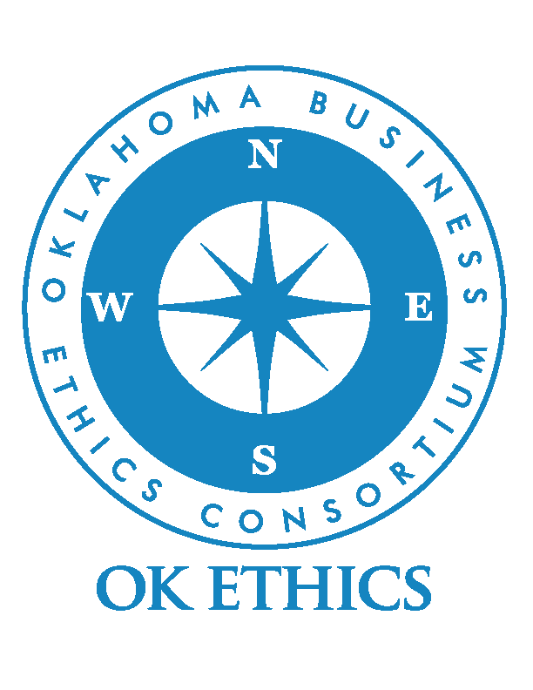OKLAHOMA BUSINESS ETHICS CONSORTIUM
CONFLICTS OF INTEREST & CONFIDENTIALITY STATEMENT

As a member of the Oklahoma Business Ethics Consortium’s Compass Award Selection Team, I represent to OK Ethics, to the best of my knowledge, as follows:

1. I have an ownership, investment interest or personal relationship with a Compass Award candidate:
_____ Yes _____ No

2. I have checked “Yes” for statement No. 1. Accordingly, I wish to disclose to
OK Ethics that:

◻ I have an ownership or investment interest in __________________________

◻ I am compensated by (>insert applicant name of company<) ________________ for: __________________________

3. No members of my immediate family transact any business with the Compass Award candidates and no members of my immediate family own an interest in or are employed by any company or business that transacts business with the Compass Award candidates, except as follows (if none, state “none”):
___________________________________________________________________
If any situations arise that contradict any of the above statements or could potentially compromise the Compass Award selection process, I will promptly notify the Founder of OK Ethics, Shannon Warren, or one of the Compass Awards Chairpersons (Mike Strong or Edith Steele). Additionally, I will provide full disclosure to the Board of Directors regarding the circumstances of the conflict.

Further, I understand that, in keeping with the spirit of the award, the focus should be on the best practices by the companies achieving finalist or recipient designations. To that end, each Selection Team member is asked to avoid detracting from those organizations’ efforts by NOT DISCLOSING THE NUMBER OF APPLICANTS for the award. Additionally, I agree not to divulge the names of companies THAT do not receive a Compass Award acknowledgement.

Signature Date

